**ANALYSING HOUSING PRICES METROPOLITAN AREAS ON INDIA**

1. INTRODUCTION
   1. Overview

This disparity in development, like many other Indicators, has also been reflected in India.

* 1. Purpose

To keep a pulse on broader economic trends and potential shifts in the stock market.

1. PROBLEM DEFINITION AND DESIGN THINKING
   1. Empathy map

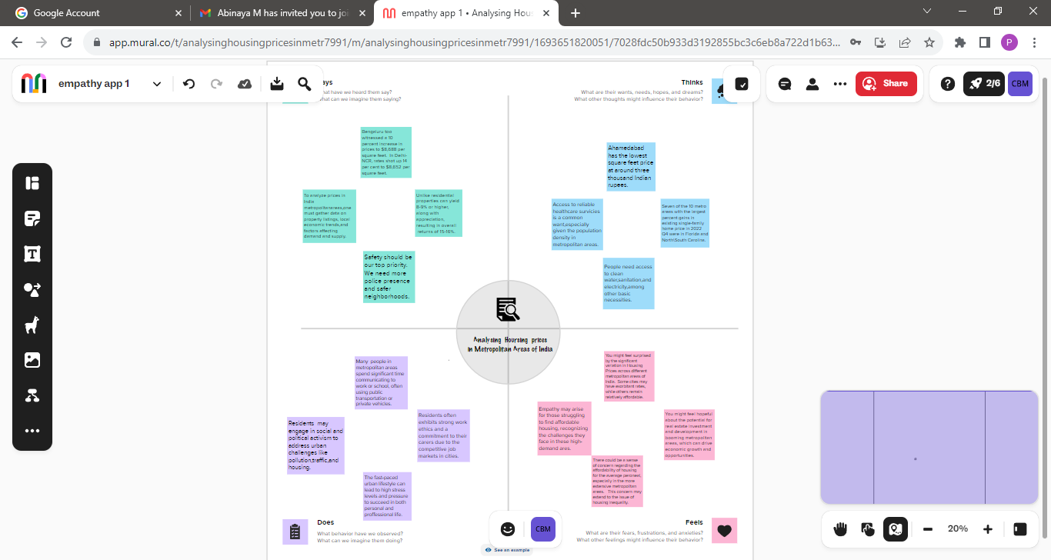

* 1. Ideation &Brainstorming Map

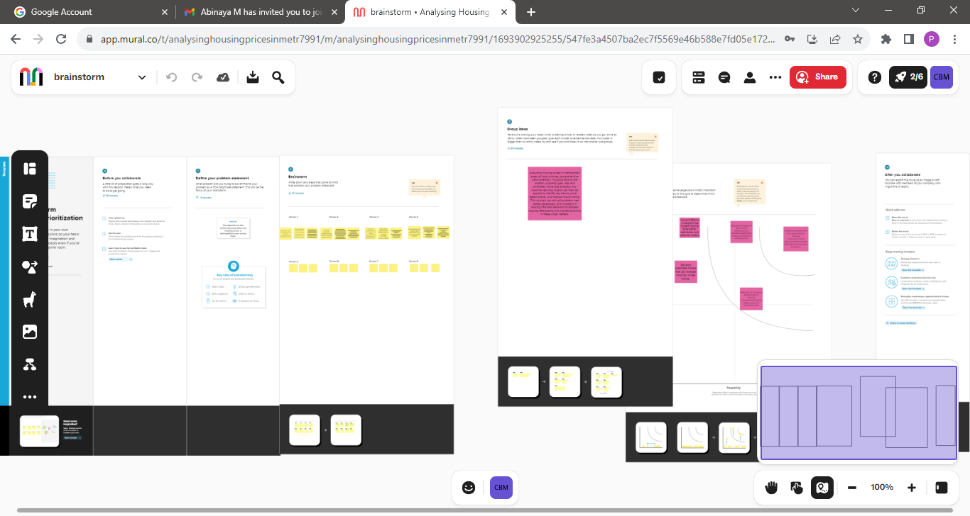

3. ADVANTAGES

* Housing prices in India have surged .
* During the first quarter of 2023 with the average price.
* Across all the major realty markets being close to 7%.

4.APPLICATION

Help the developer determine the selling price of a house and can help the customer to arrange the right time to purchase a house.

5. CONCLUSION

House price in the 15 metropolitan cities do not converge to the loop.

6. FUTURE SCOPE

The real estate market is expected to grow significantly in India.

Demand for homes sours, prices .

Follow suit.

7. APPENDIX

SOURCE CODE:

Help people who plan to buy a house. So they expected to have the selling price of similar properties in the vicinity.